Reviewer Note: Reviews for this pattern are due Sept 21st.
Data Transfer RowSet

When using JDBC for Reading, relational data needs to be transferred across the network tier from the Session Façade to the client.

How can relational data be transferred to the client in a generic, tabular format?
* * *
The JDBC for reading pattern advocates the practice of using Session beans to perform straight JDBC calls to the database (instead of querying through the entity bean layer) when performing common read-only listing of tabular data, such as populating tables on HTML pages or applets. This practice can improve performance if you are using BMP, or if your CMP engine does not support bulk loading of entity bean data, or if you cannot make use of entity bean caching (see the JDBC for Reading pattern for more info).
With the Session Façade performing JDBC calls, the question then becomes: what is the best way to marshal this data across to the client? The most common solution is to use Data Transfer Objects. For example, consider the Employee/Department example used in the JDBC for Reading pattern. Here we want to populate a table that lists all employees in a company with their department, as in figure X.1.
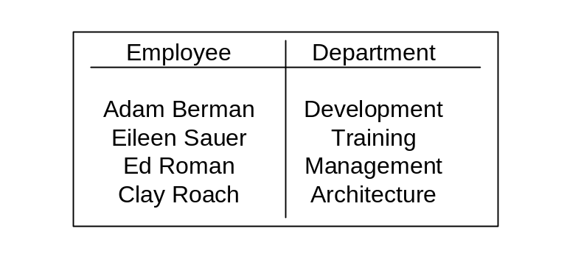

Figure X.1: HTML Table of Employees
Data Transfer Objects can be used to populate this table by creating a Custom EmployeeDepartmentDTO, which looks like the following:

public class EmployeeDepartmentViewObject {
public String employeeName;
public String employeeTitle;
...
public String departmentName;
public String departmentLocation;
...
}
Here, the Session bean will perform a JDBC call to get a ResultSet that contains information about an employee and their department. The session bean will then manually extract fields from the ResultSet and call the necessary setters to populate the DTO. Each row in the ResultSet will be transferred into a DTO which will be added to a collection. This collection of DTO’s now forms a network transportable bundle, transferable to the client for consumption.

As explained in the Data Transfer HashMap pattern, using DTOs as a data transport mechanism causes maintainaibility problems due to the often very large DTO layer that needs to be created, as well as the fact that client UI’s are tightly coupled to the DTO layer. When using JDBC for Reading, DTO’s suffer an additional problem:
Performance: tabular to OO and back to tabular is redundant. With the data already represented in rows in tables in a result set, the transferring of the data into a collection of objects and then back into a table (on the client UI) consisting of rows and columns is redundant.
When using JDBC for Reading, ideally a data transfer mechanism should be used that can preserve the tabular nature of the data being transferred in a generic fashion, allowing for simpler clients and simpler parsing into the client UI.
Therefore,
Use RowSets for marshalling raw relational data directly from a ResultSet in the EJB tier to the client tier.

Introduced in JDBC 2.0, a RowSet is an interface, a subclass of java.sql.ResultSet. What makes RowSets relevant to EJB developers is that particular implementations the RowSet interface allow you to wrap ResultSet data and marshal it off to the client tier, where a client can operate directly on the rows and fields in a RowSet as they might on a Result Set. JDBC 2.0 introduces such an implementation called a CachedRowSet. A CachedRowSet allows you to copy in ResultSet data and bring this data down to the client tier, because a CachedRowSet is disconnected from the database. Once the CachedRowSet has been initialized with data, database connections can be closed – the CachedRowSet now maintains a copy of the results of the SQL query.
From our Employee and Department example, using RowSets would allow us to retrieve an entire table of Employee and Department data in one object and pass that on to the client tier. Figure X.2 illustrates how the RowSet approach differs from the Data Transfer Object approach.
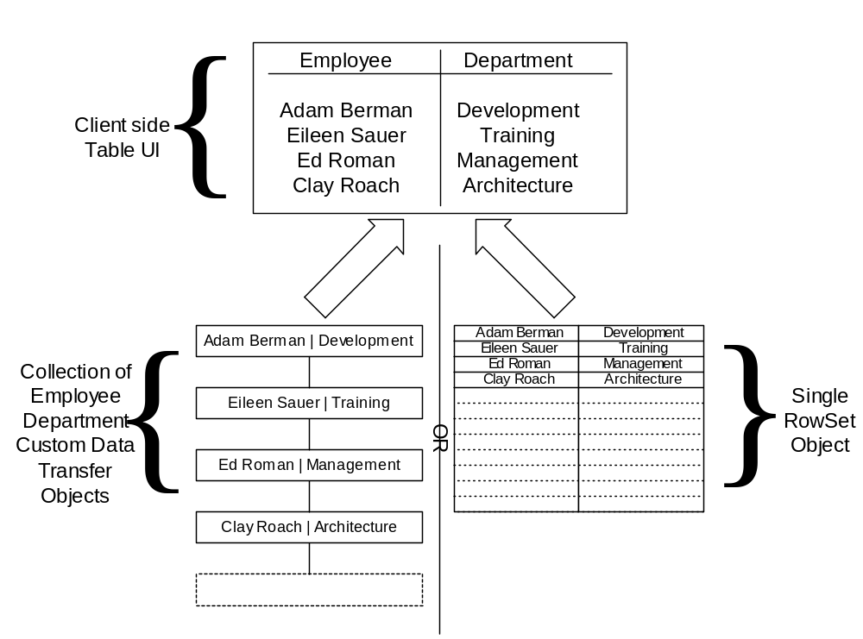
Figure X.2: Value Objects vs. RowSets

On the client tier, the data from the RowSet can now be directly mapped to the columns and rows of a table.
RowSets offer a clean and practical way to marshal tabular data from a JDBC ResultSet, straight down to the client side UI, without the usual overhead of converting data to Data Transfer Objects and then back to tabular client side lists.
Using RowSets as a method of marshalling data across tiers brings many advantages:
RowSet provides a common interface for all query operations. By using a RowSet, all the clients can use the same interface for all data querying needs. No matter what the use case is or what data is being returned, the interface a client operates on stays the same. This is in contrast to having hundreds of client UI’s tightly coupled to use case specific Custom DTO’s. Whereas Data Transfer Objects need to be changed when the client’s data access needs change, the RowSet interface remains the same.
Eliminates the redundant data translation. RowSets can be created directly from JDBC ResultSets, eliminating translation step from ResultSet to DTO and then back to a table on the client side.
Here are the tradeoffs:
Clients need to know the name of database table columns. Clients should be insulated from persistence schema details such as table column names. Using RowSets, a client needs to know the name of the column used in the database in order to retrieve an attribute. This problem can be alleviated by maintaining a ‘contract’ of attribute names between client and server, as described in the Generic Attribute Access pattern.
Not object oriented. The move away from the object paradigm may seem somewhat contrary to most J2EE architectures based on Data Transfer Object/entity beans After all, dumping a bunch of data into a generic tabular object appears to be a very non-OO thing to do. When using RowSets, we are not attempting to mirror any business concept, the data itself is the business concept that is being presented to the user, and not any relationships between the data.
No compile-time checking of query results. Rather than calling getXXX() on a value object, a client must now call getString(“XXX”) on the RowSet. This opens up client side development to errors that cannot be caught at compile time, such as the mistyping of the attribute name a client wants to retrieve from the RowSet.

One important point to remember is that although some implementations of the RowSet interface are updateable and can synchronize their changes with the database, a developer should never use this facility to perform updates in an application. Updates should be performed by passing parameters to methods on the session façade or using Data Transfer Objects. Data Transfer RowSets are only used for read only data, in conjunction with the JDBC for Reading pattern.

